**PHP Internship Report**

**Personal Details**

Name : Patel nishith rakeshbhai

College Name : Aditya silver oak

Degree : CE

Semester : 5

Github URL : https://github.com/Nishith1611

**Company Details**

Company Name : Akash Technolabs

External Guide : Akash Padhiyar

Training Duration : 26-05-2021 to 21-06-2021

**Index**

| index | Task Detail | **Page Name** |
| --- | --- | --- |
| 1 | REGISTRATION FORM | 1  1 |
| 2 | Get Method | 2 |
| 3 | post Method | 3 |
| 4 | moster | 4 |
| 5 | Associativ earray | 5 |
| 6 | Numericalarray | 6 |
| 7 | Logo | 7 |
| 8 | Couth | 8 |
| 9 | Couth Values | 9 |
| 10 | Range | 10 |
| 11 | Rsort | 11 |
| 12 | php registration form | 12 |
| 13 | post method 1 | 13 |
| 14 | Fatch data | 14 |
| 15 | implode | 15 |
| 16 | pop | 16 |
| 17 | push | 17 |
| 18 | diff | 18 |
| 19 | array combine | 19 |

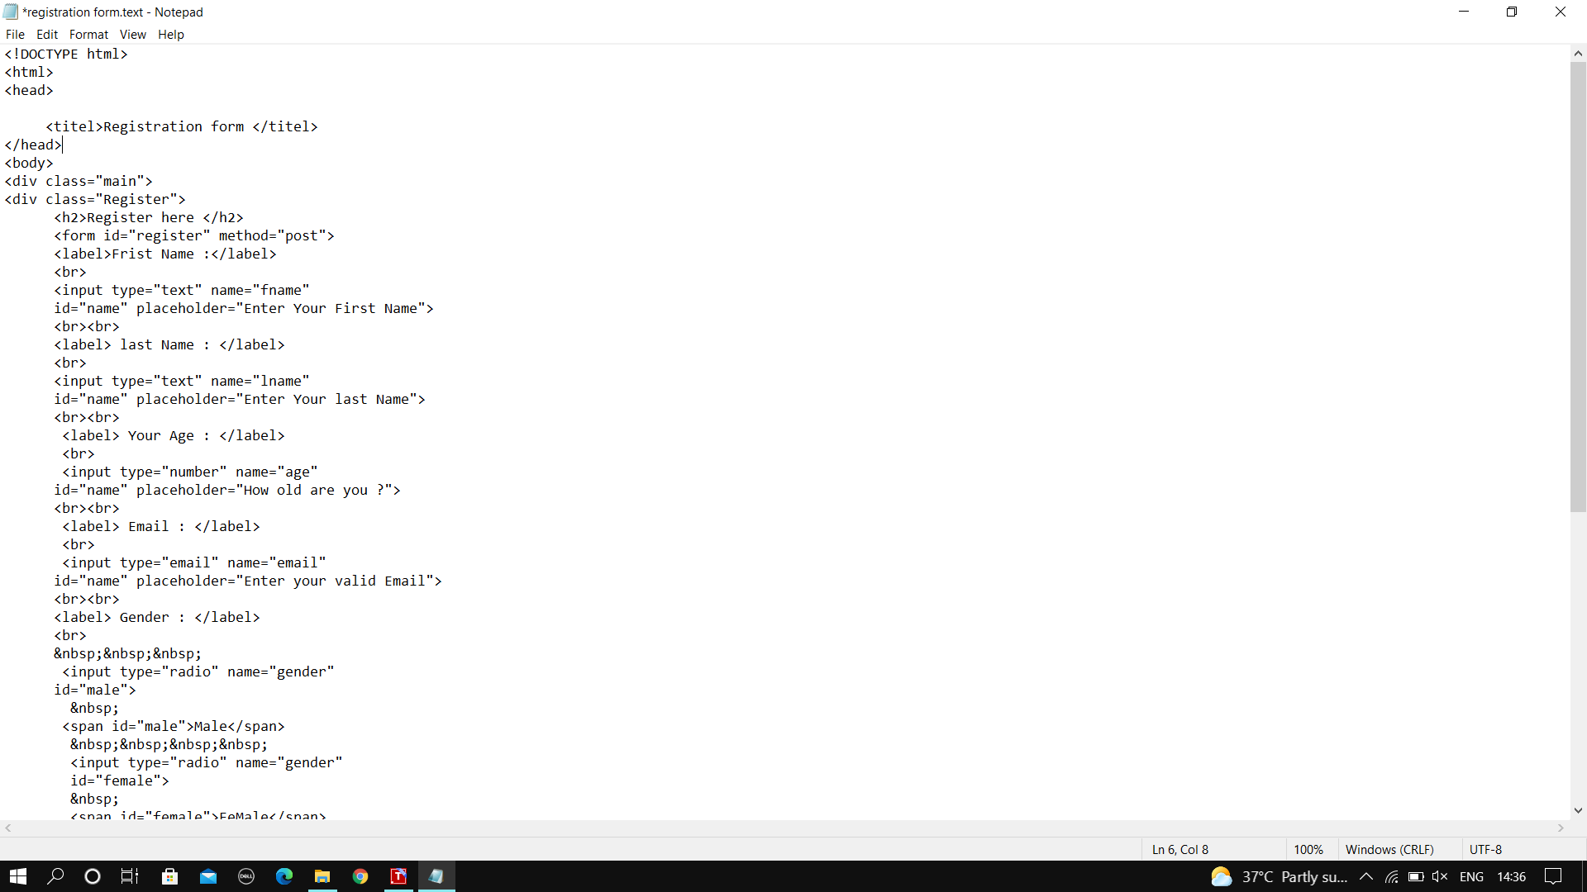**1.Registation form**

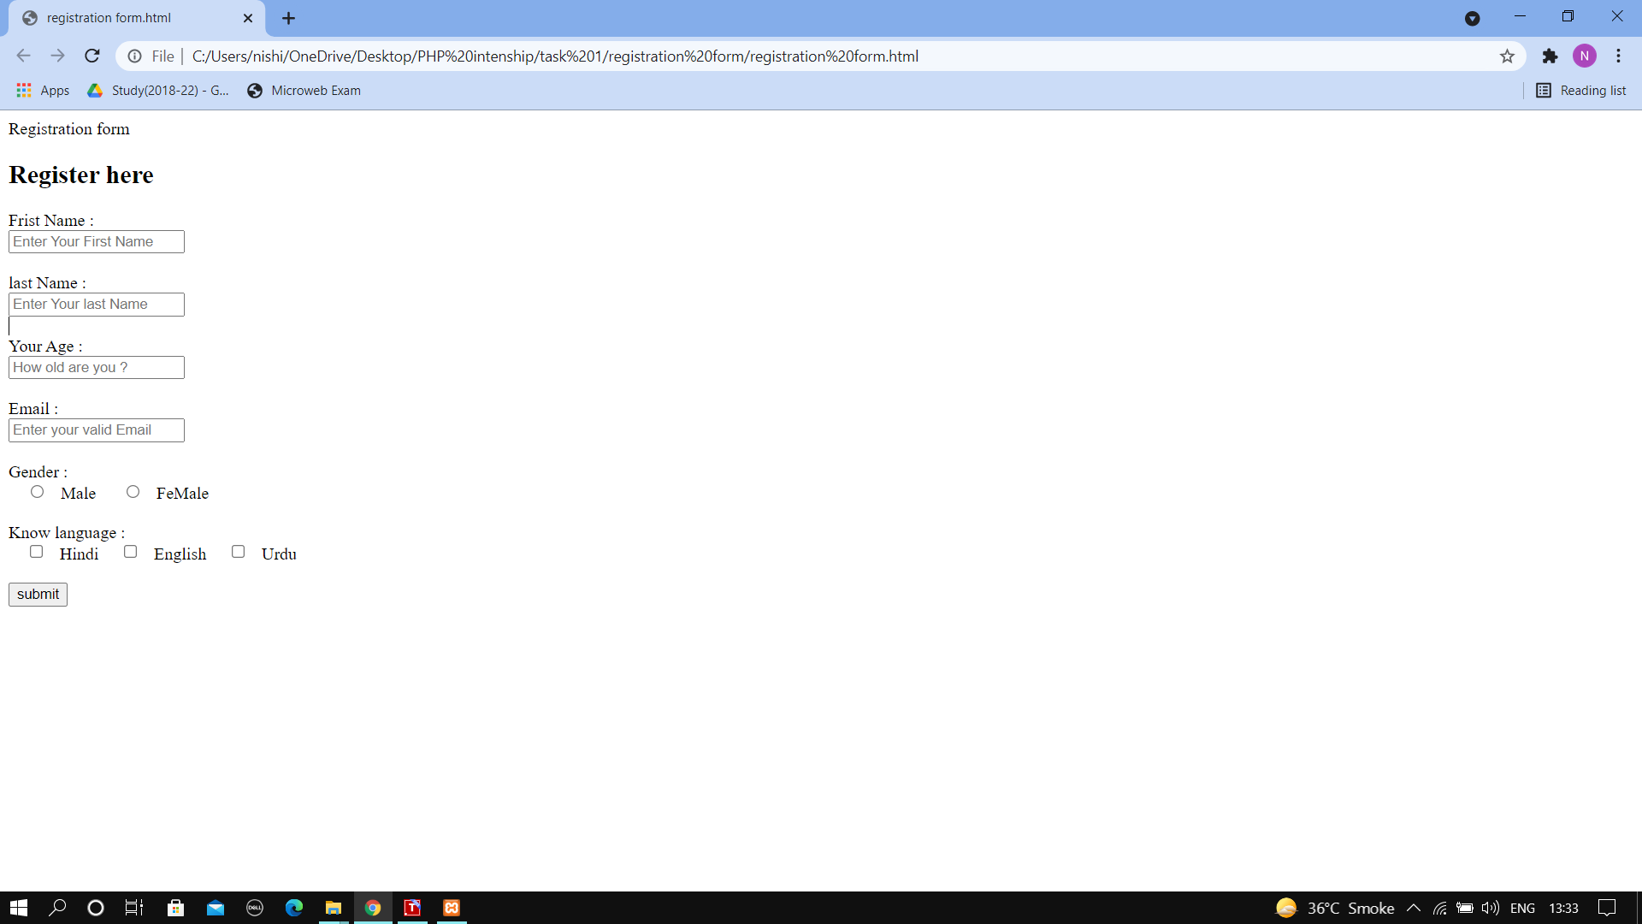**OUTPUT**

**2.Get Method**

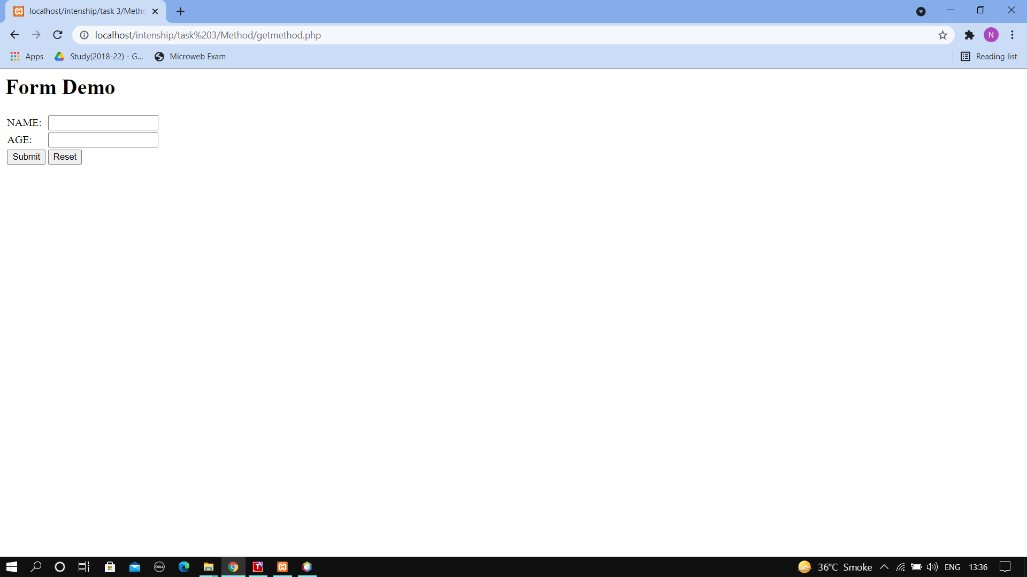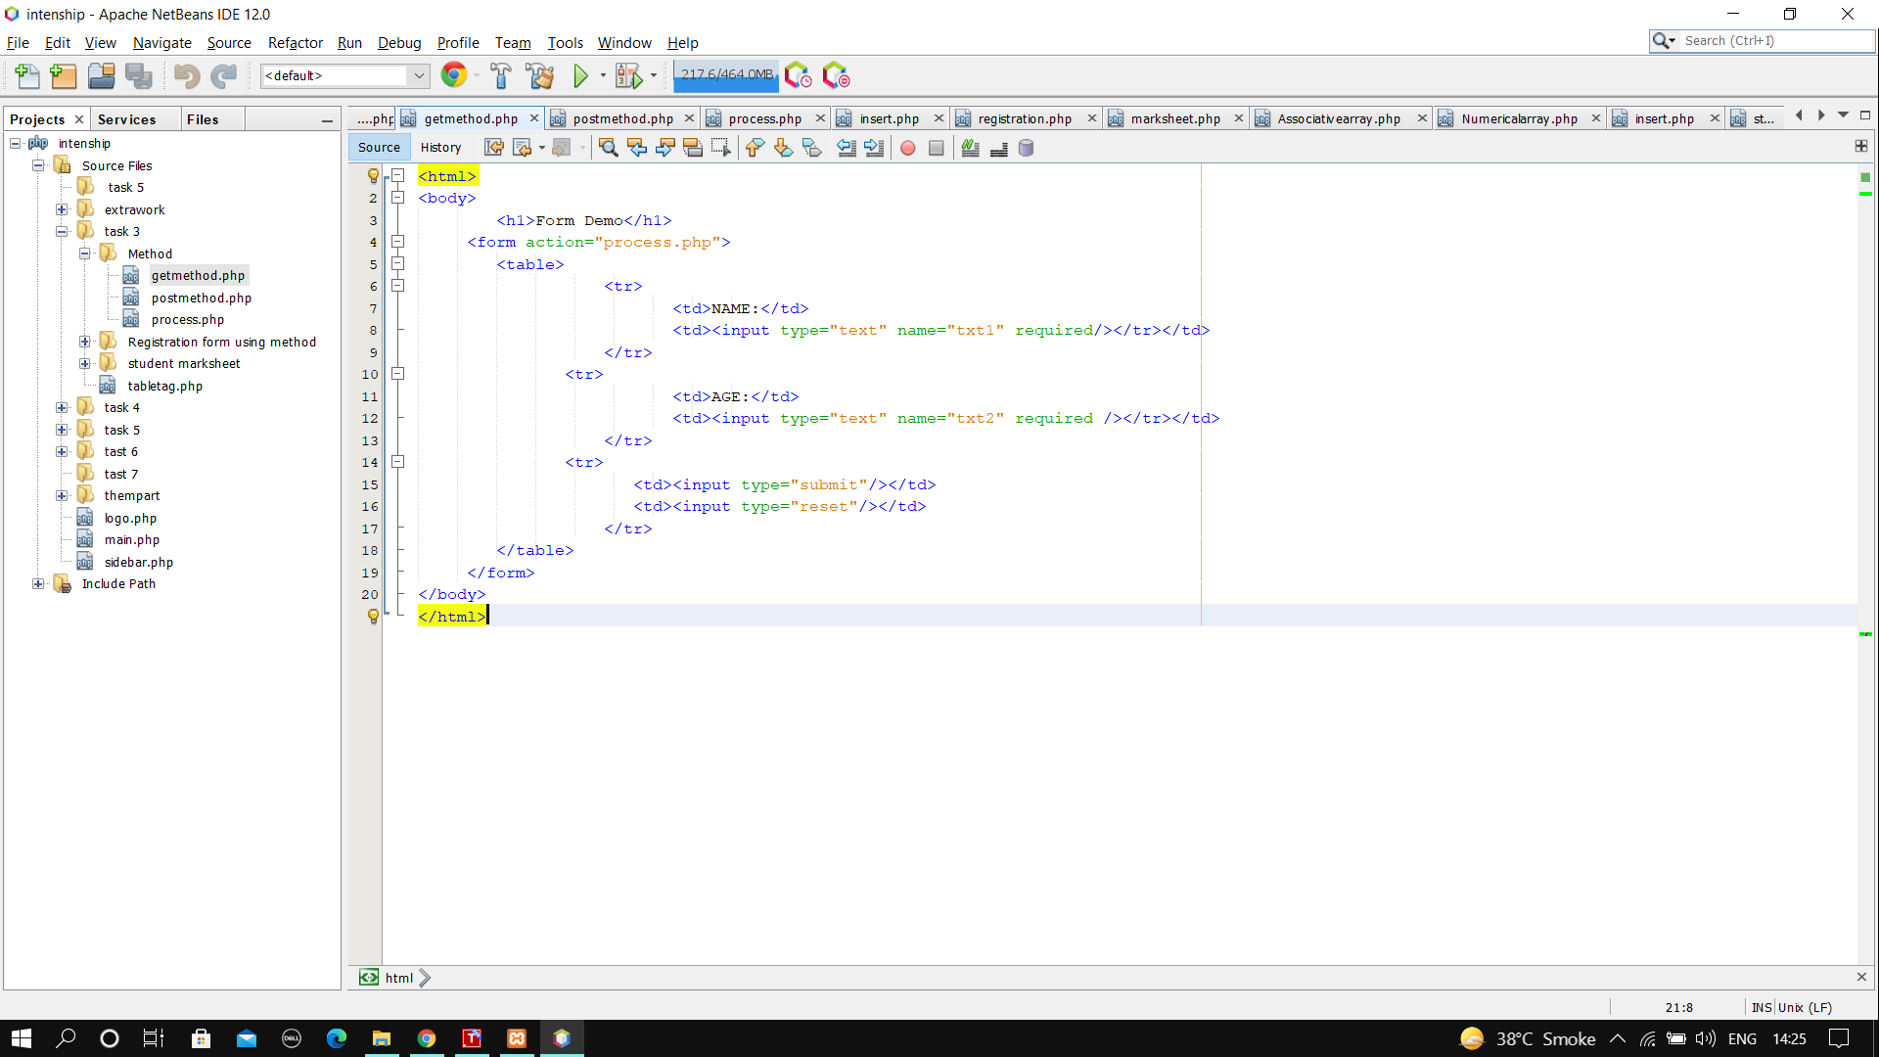

**3.post Method**

**Output**

**4.moster**

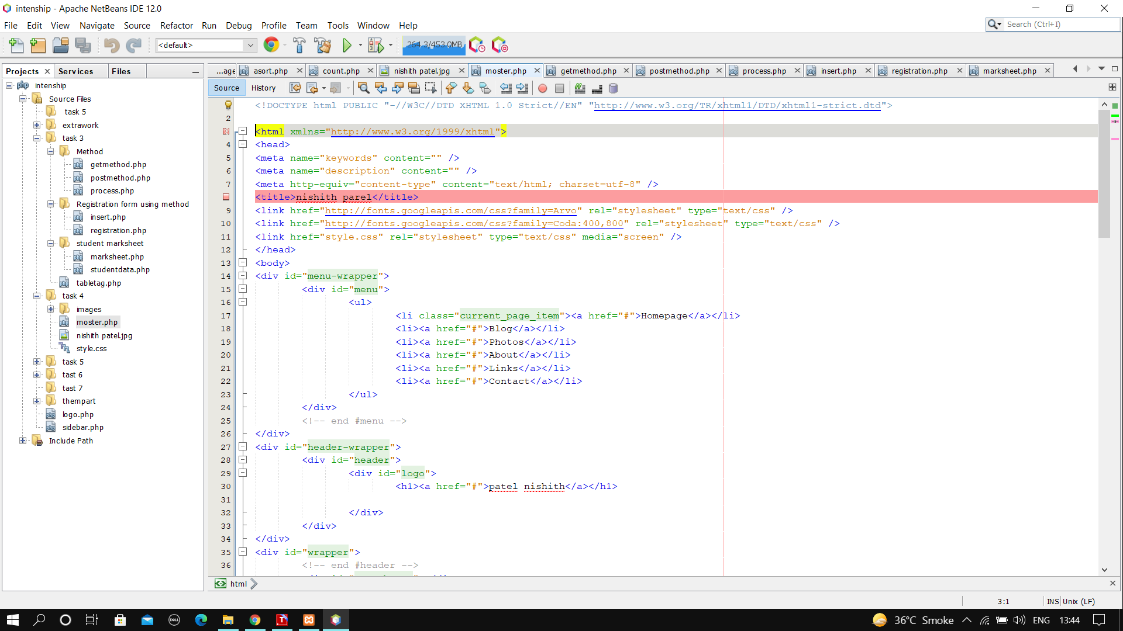

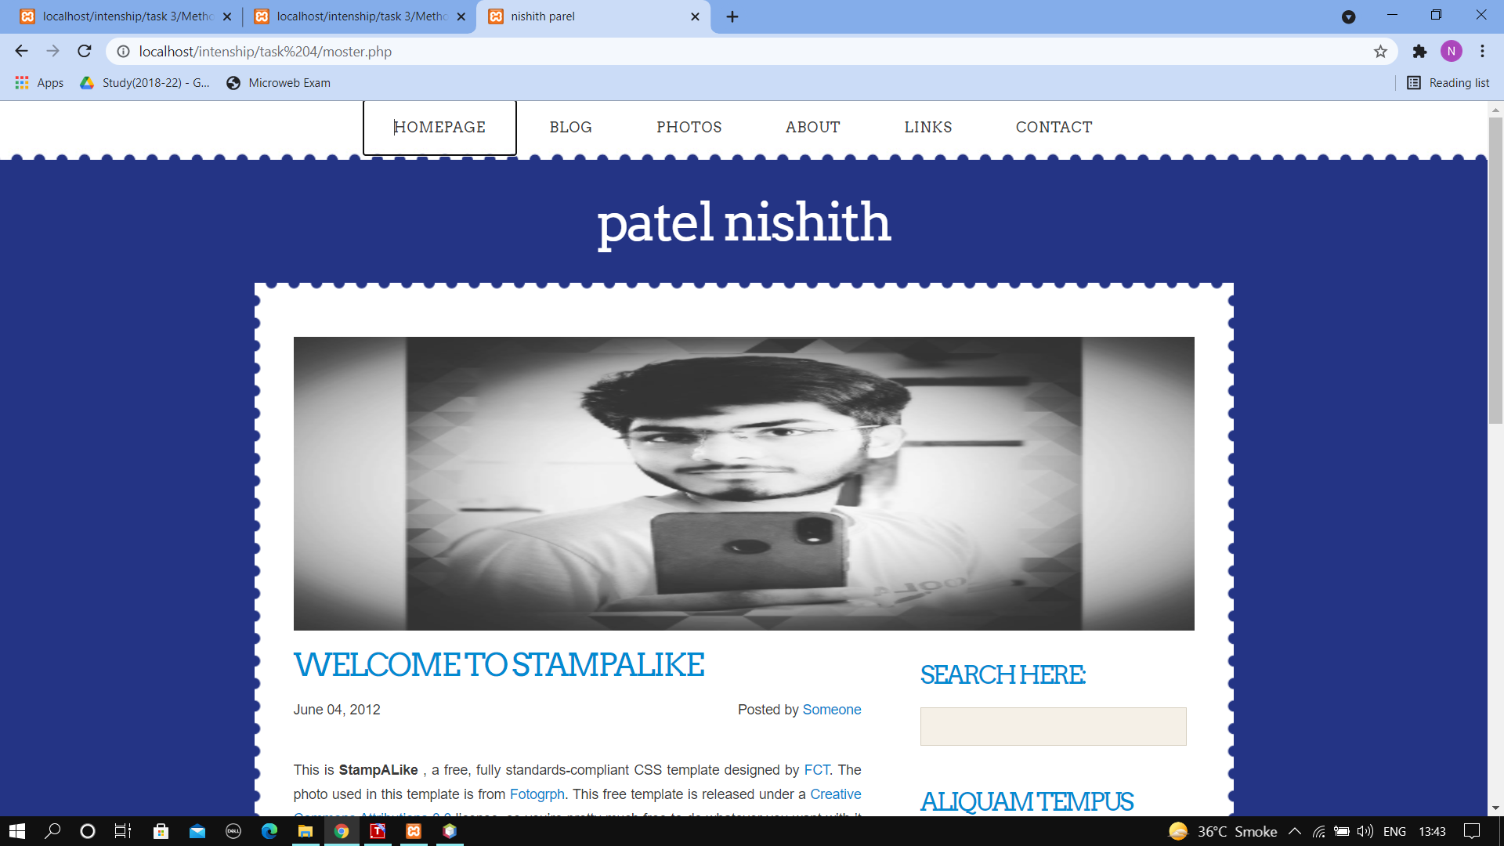**Output**

**5.Associativ earray**

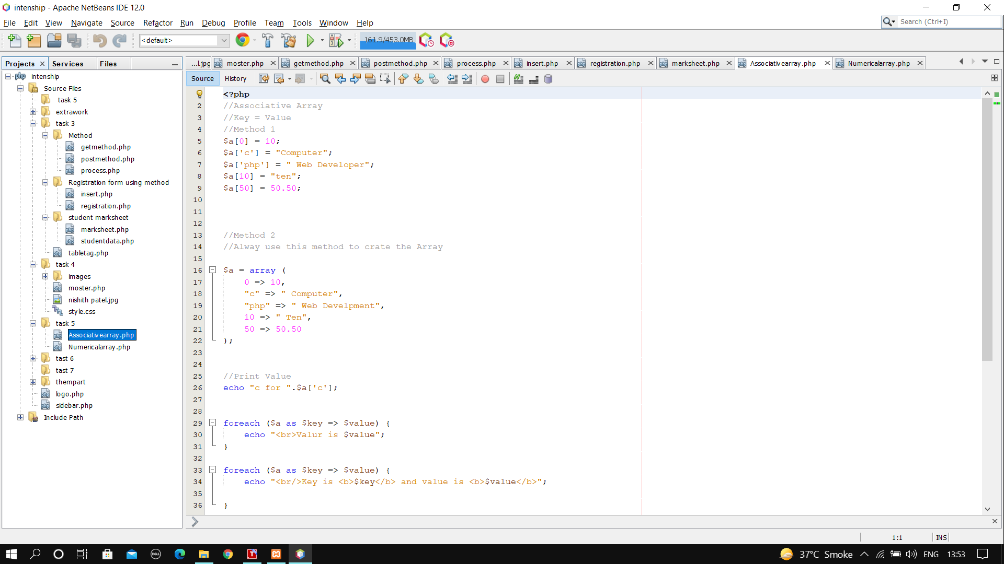

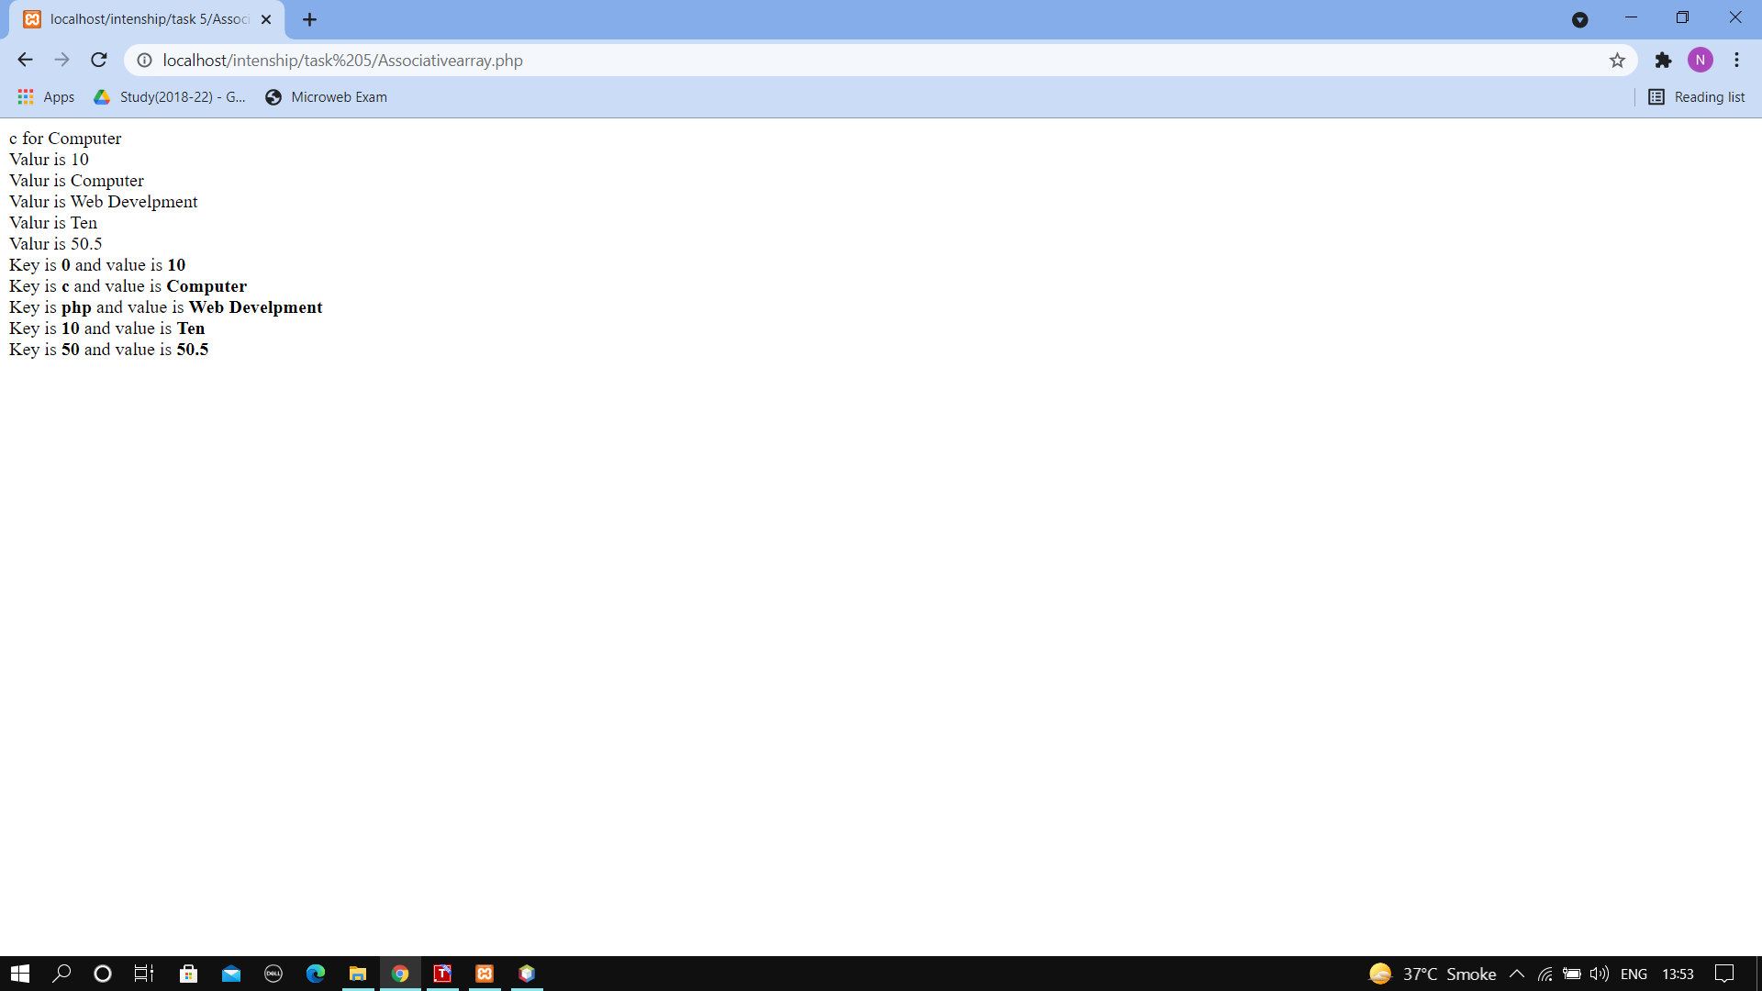**Output**

**6.Numericalarray**

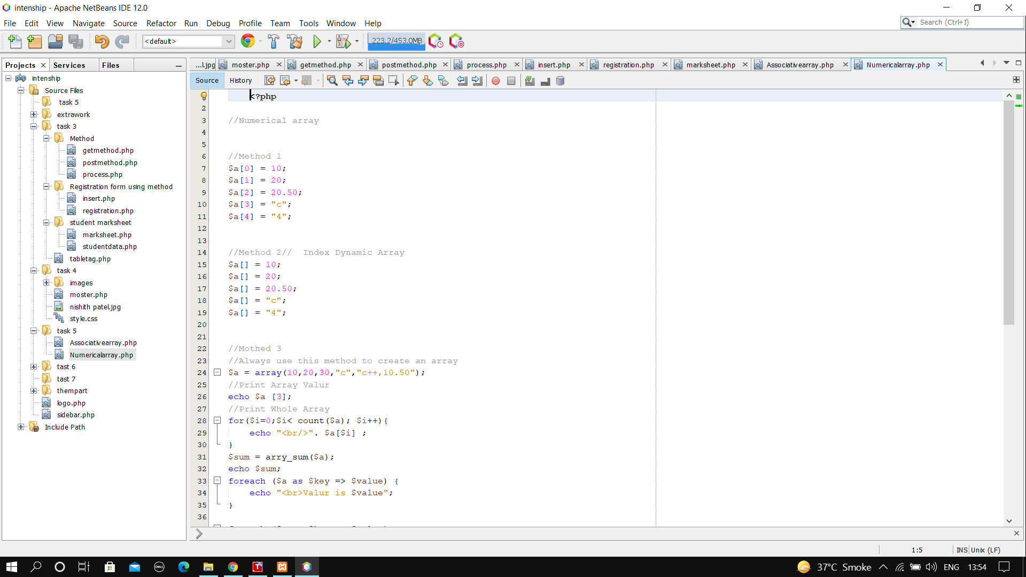

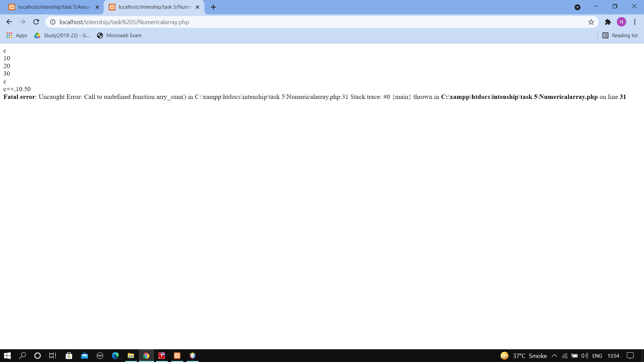**Outpur**

**7.Logo**

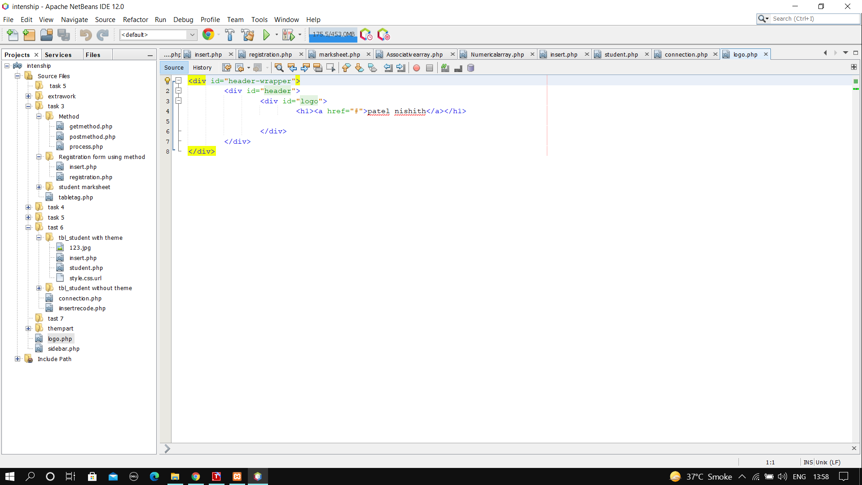

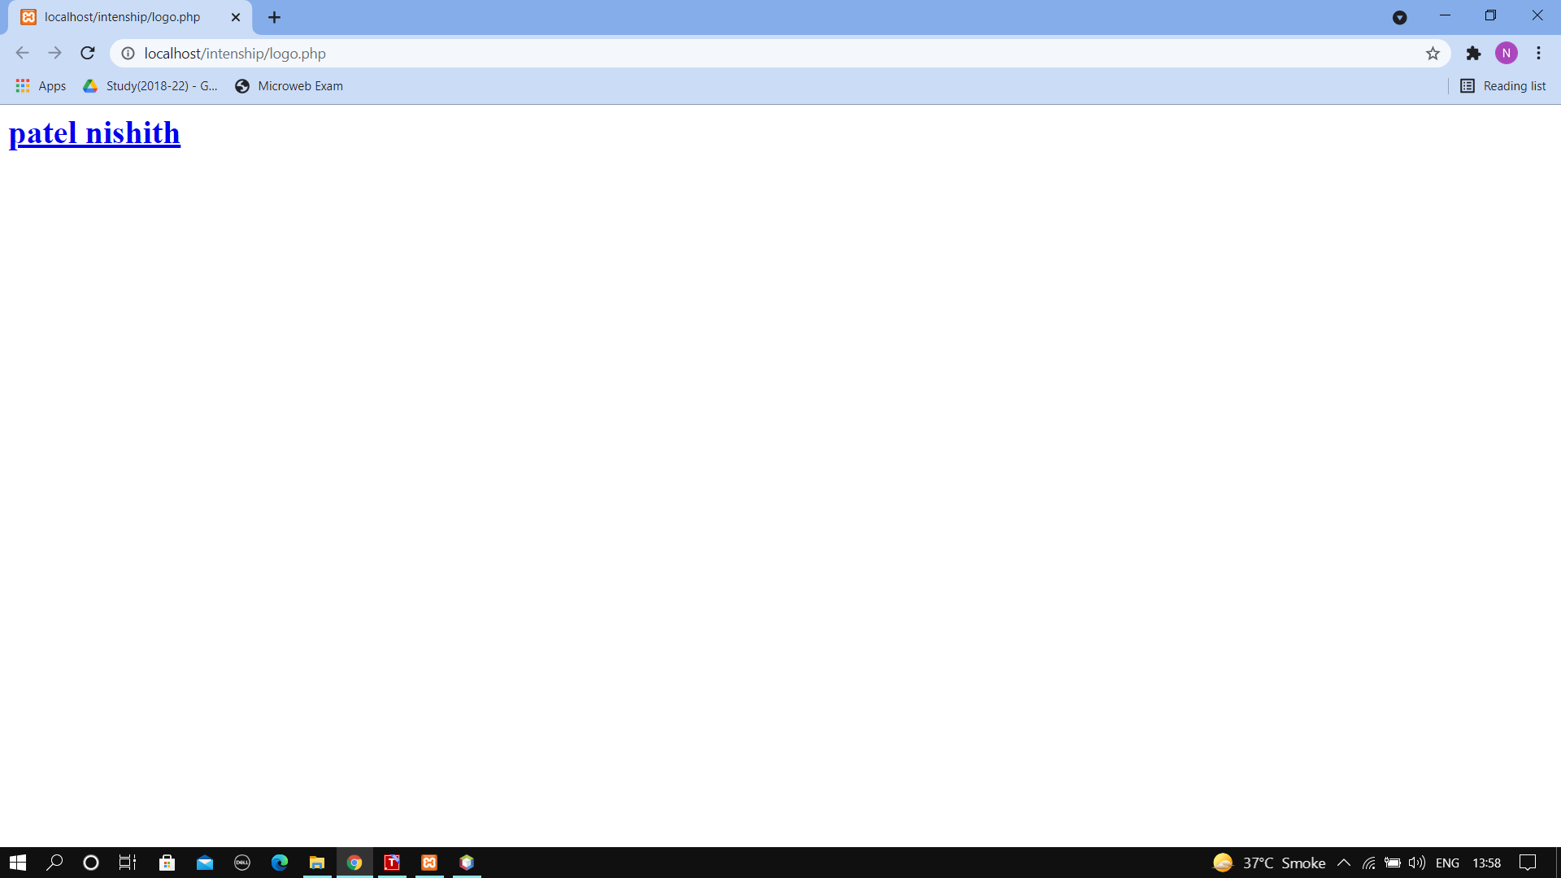**Output**

**8.Count**

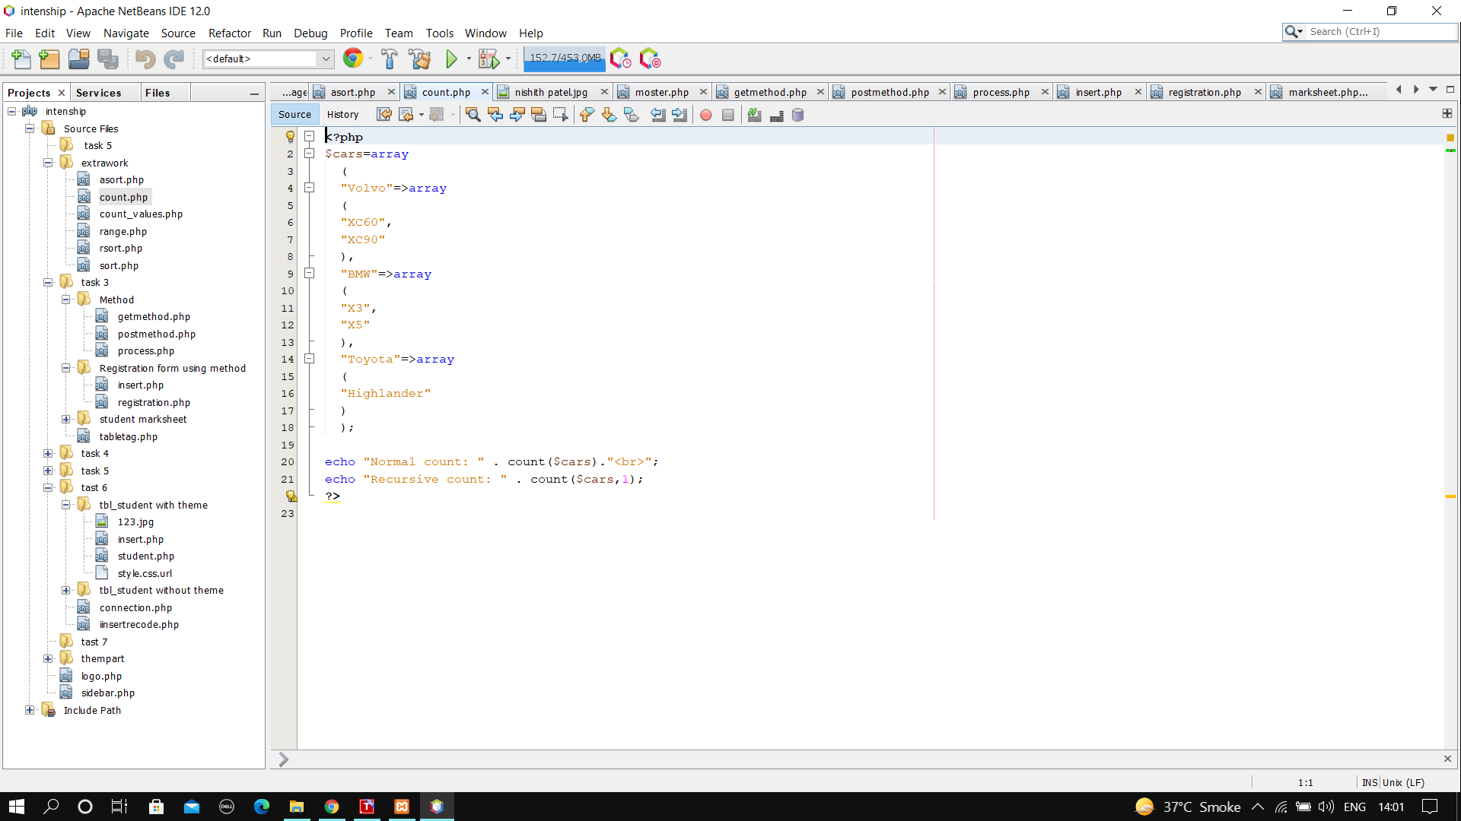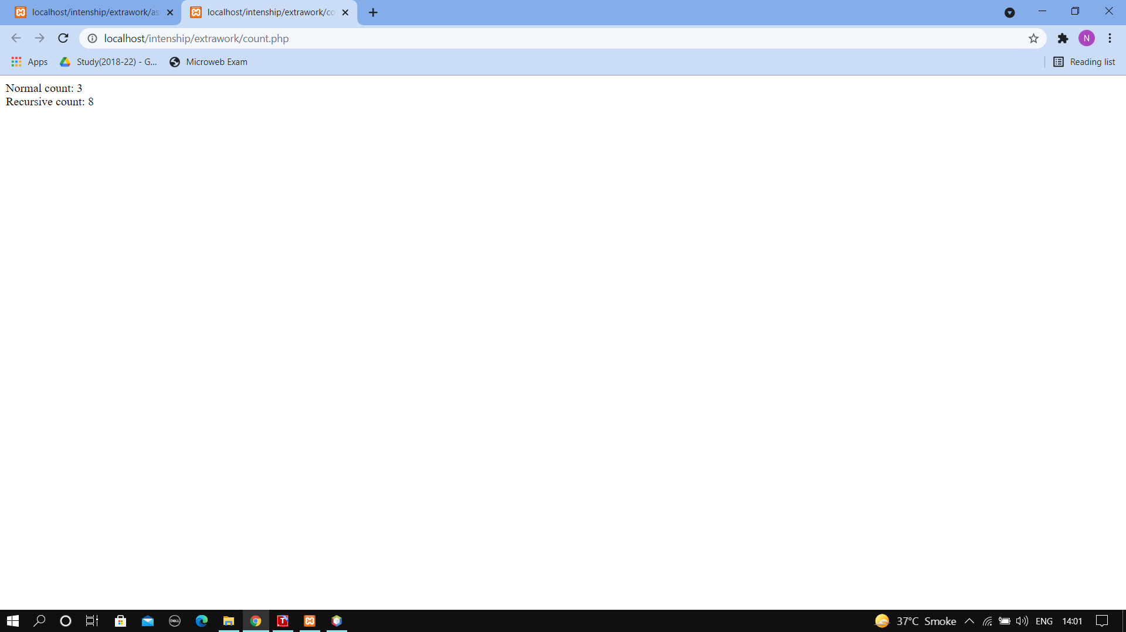**Output**

**9.Couth Values**

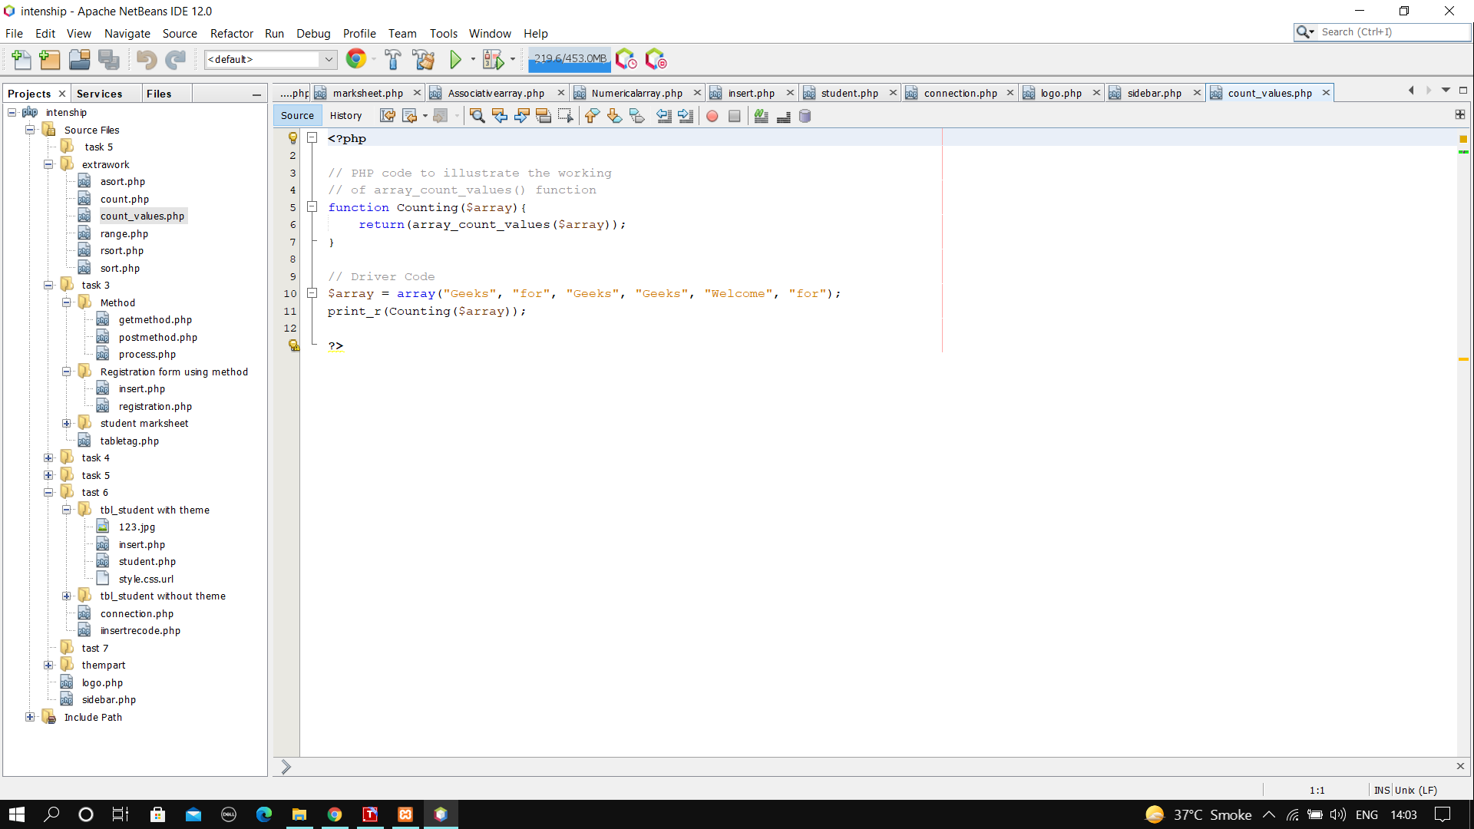

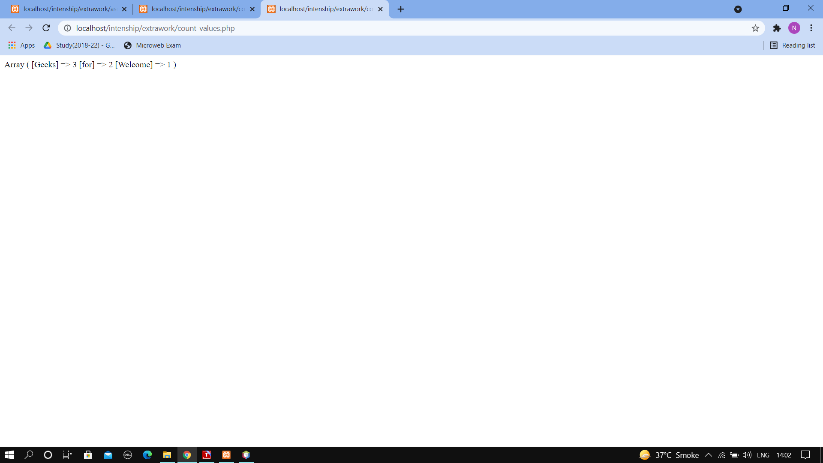**Output**

**10.Range**

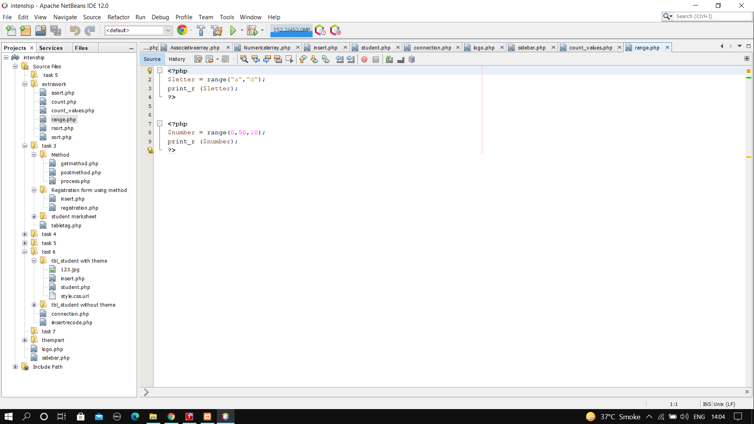

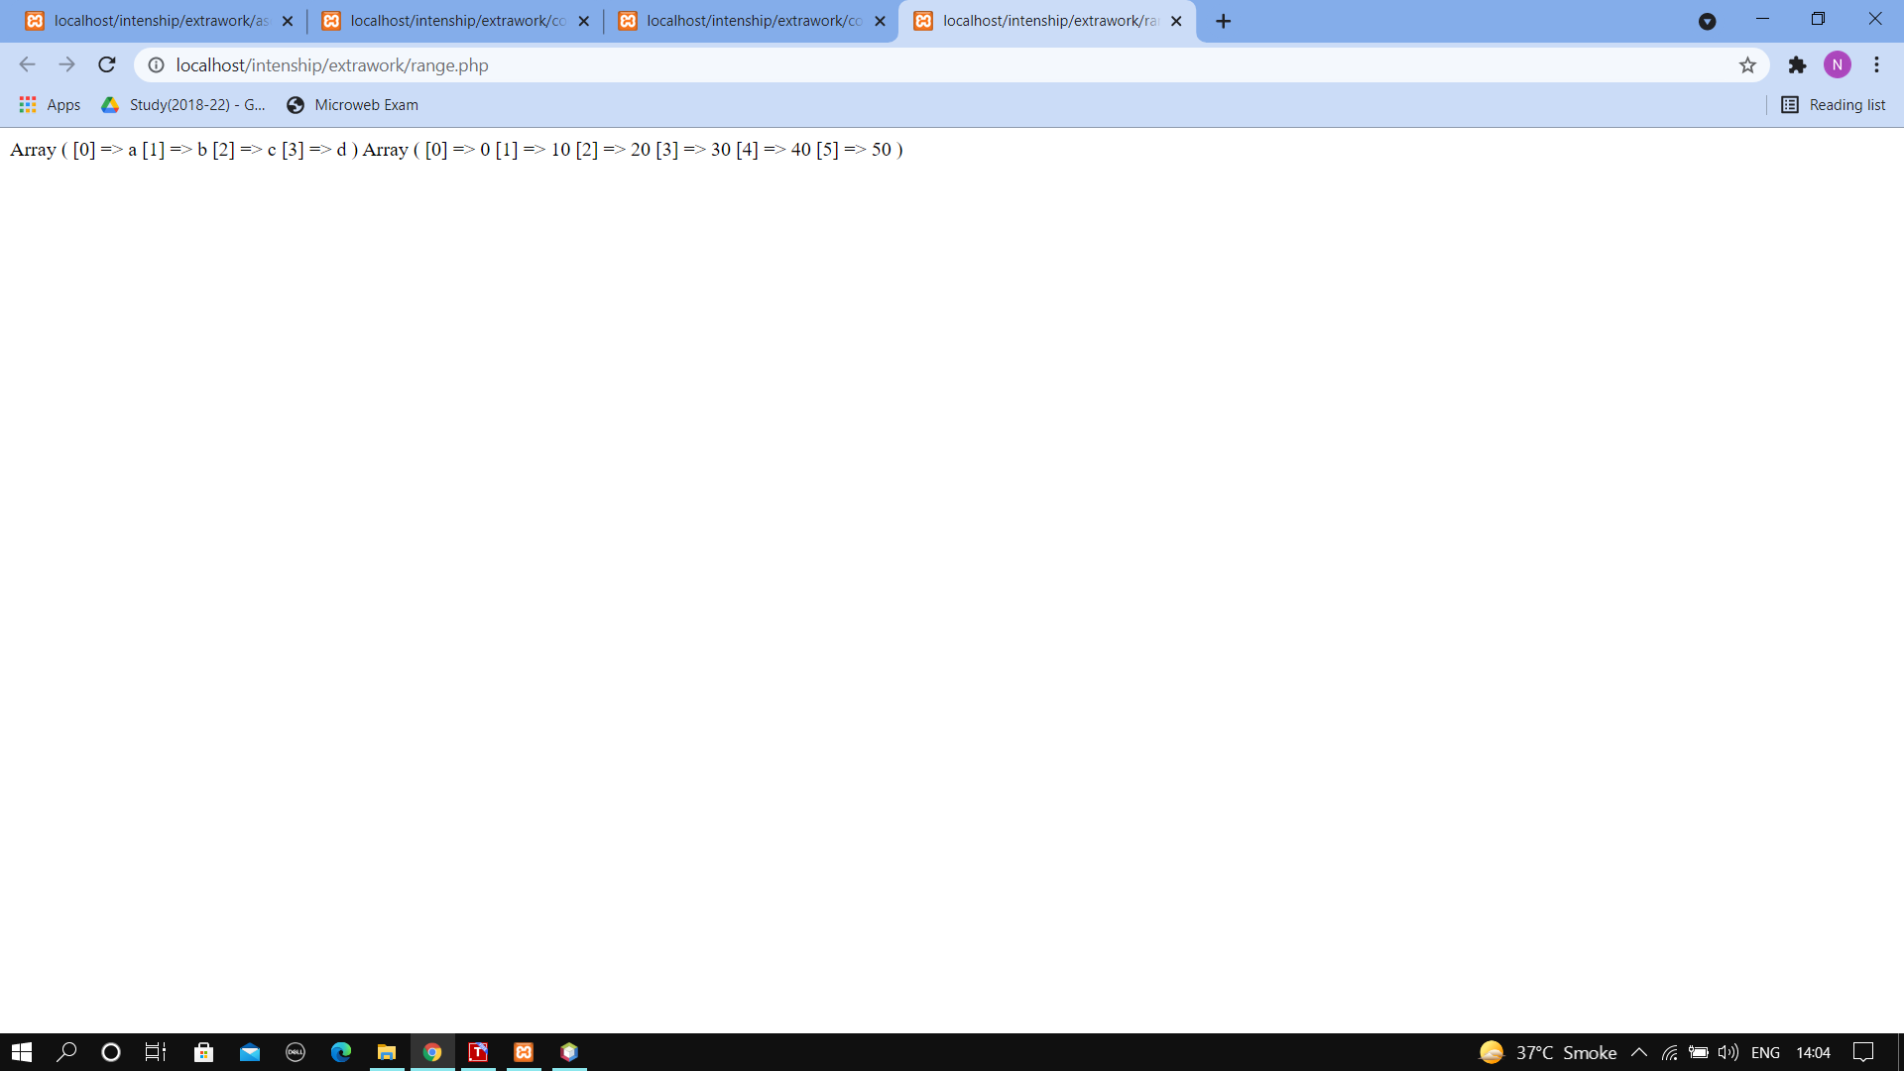**Output**

**11. Rsort**

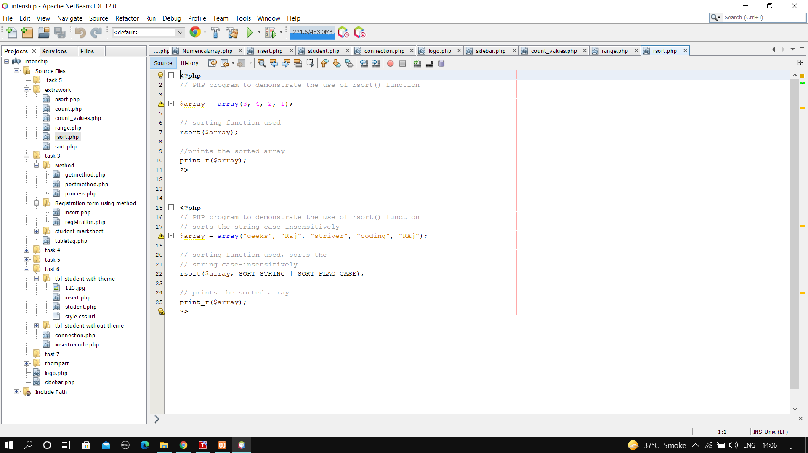

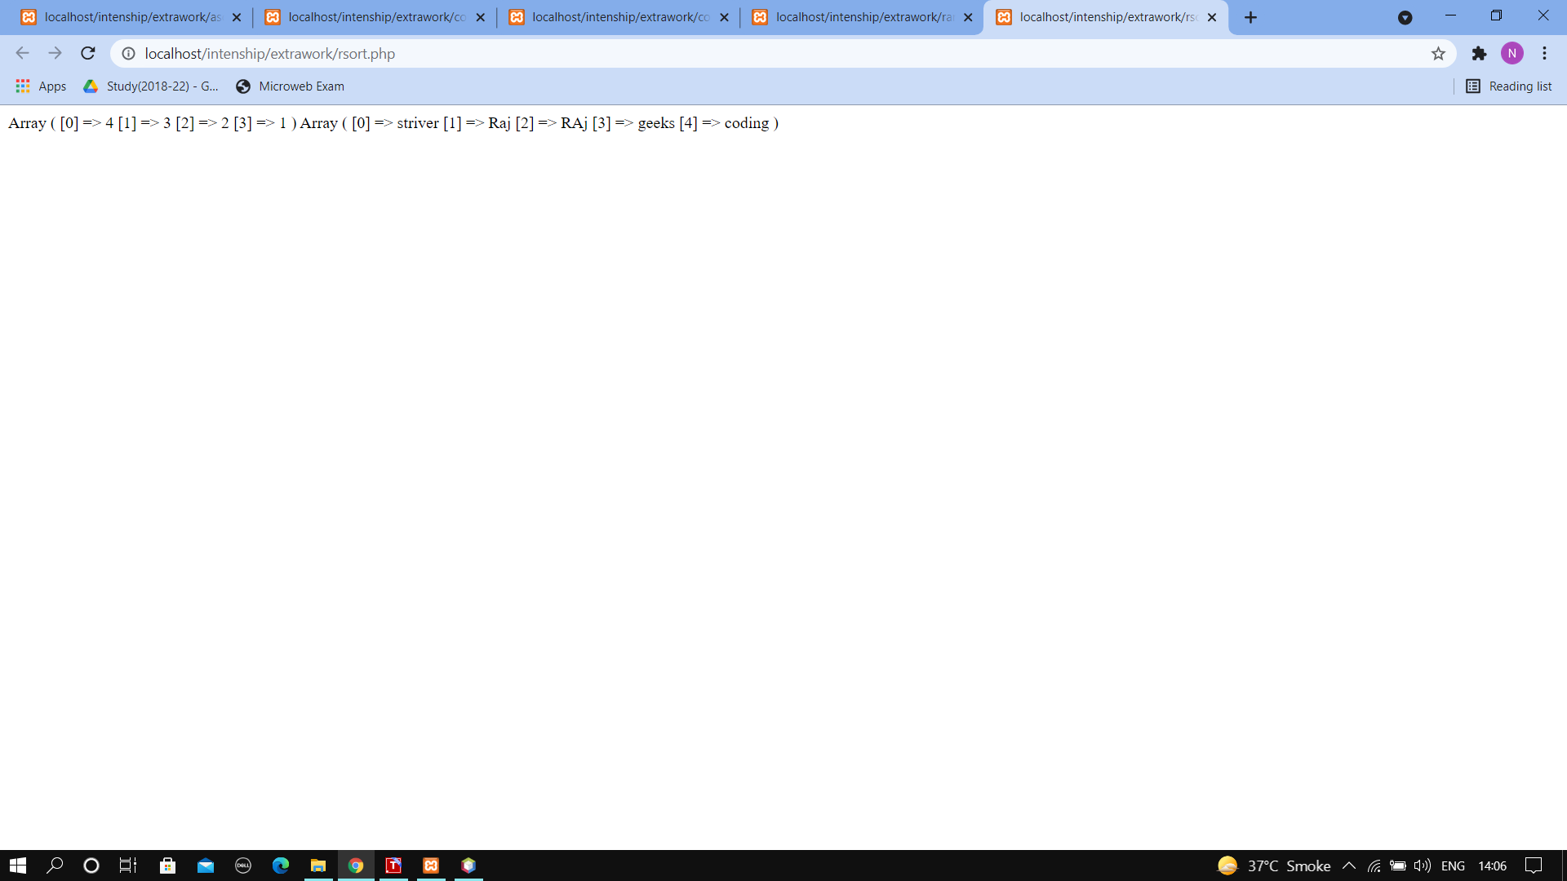**Output**

**12.php registration form**

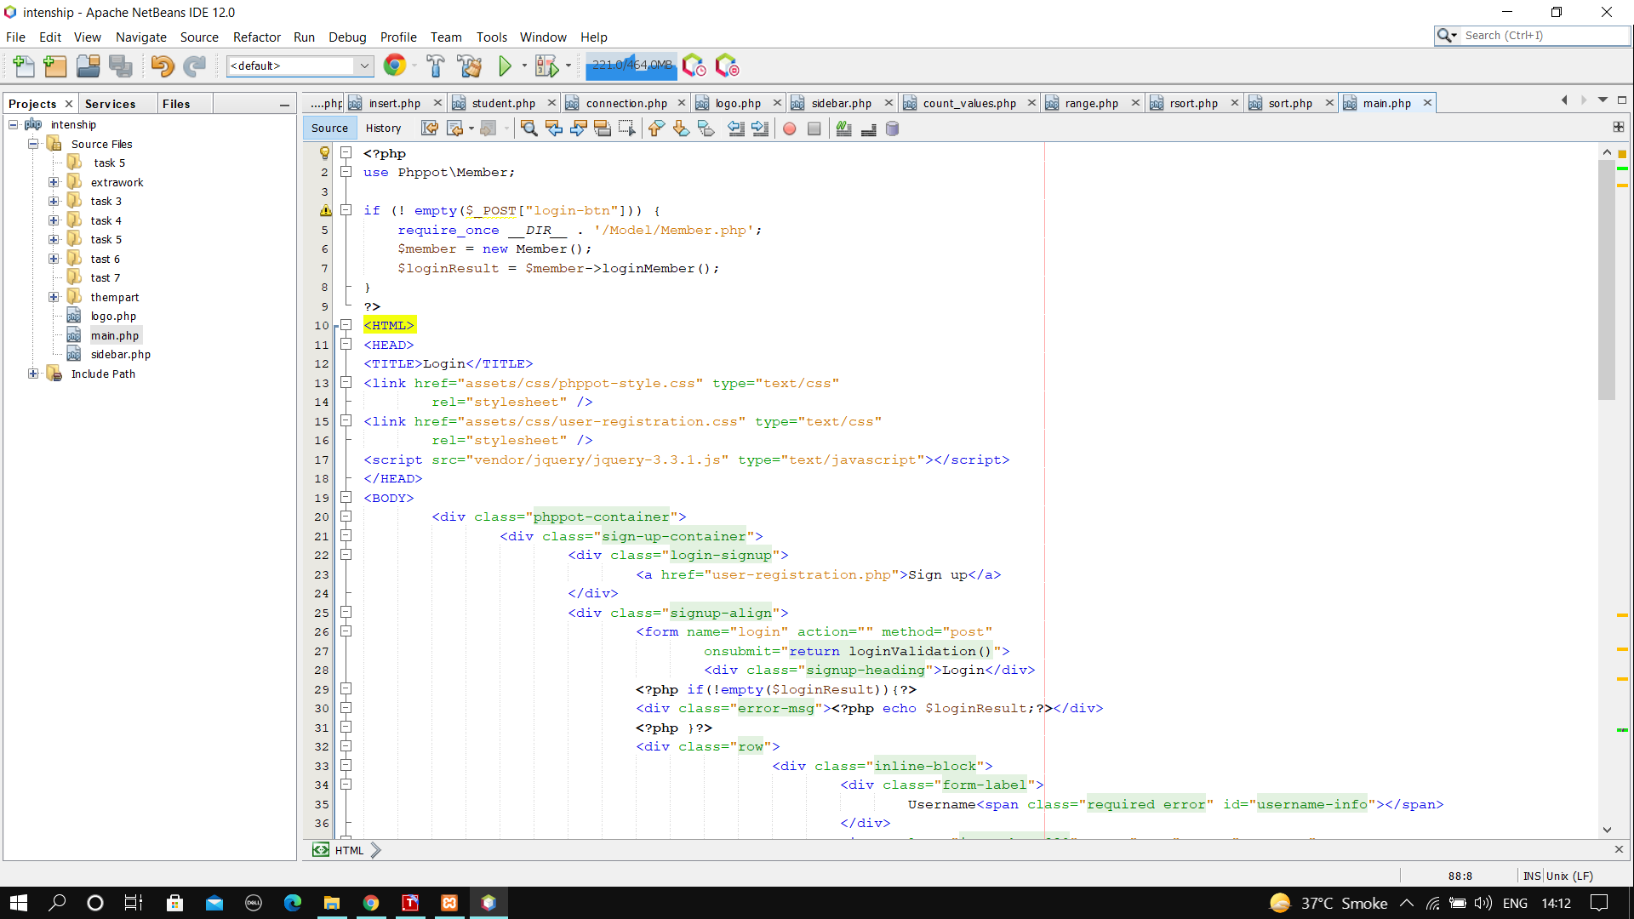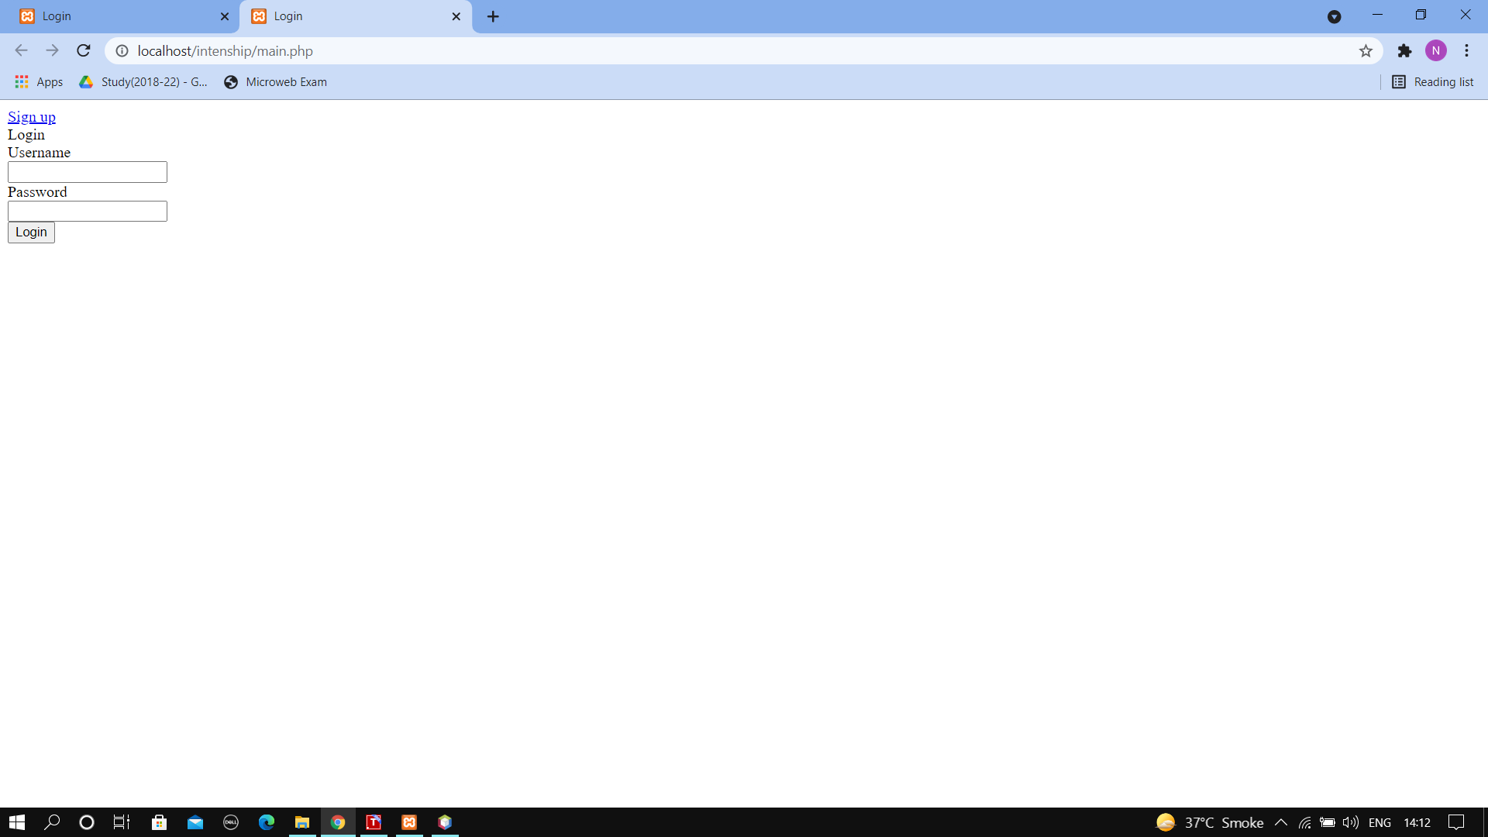

**Output**

**13.post method**

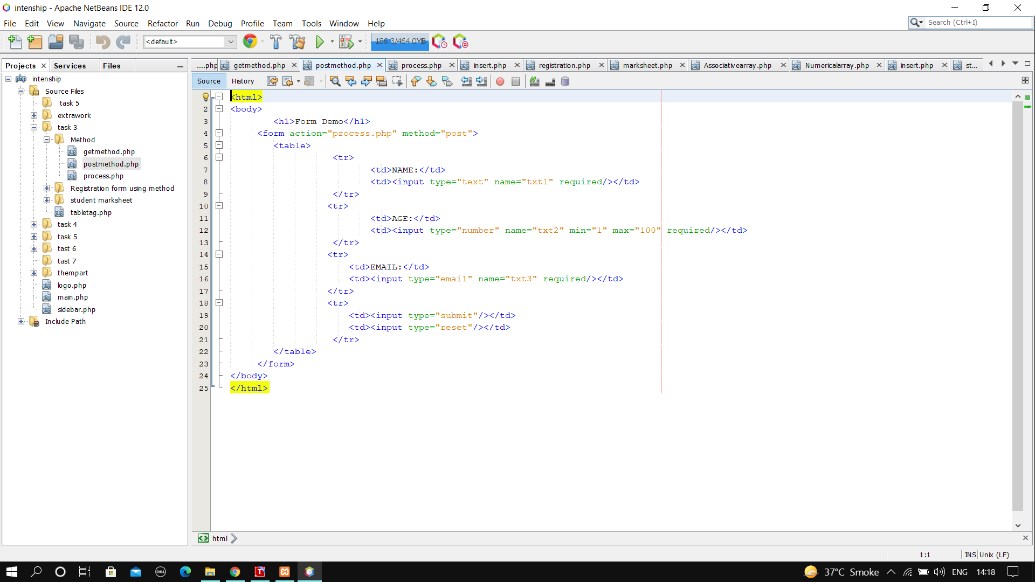

**output**

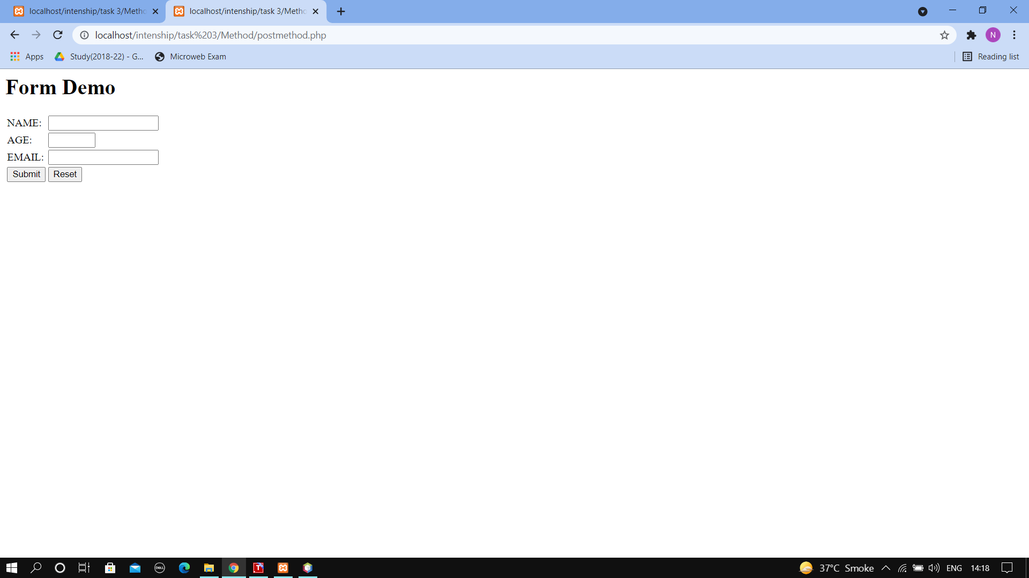

**14.Fatch data**

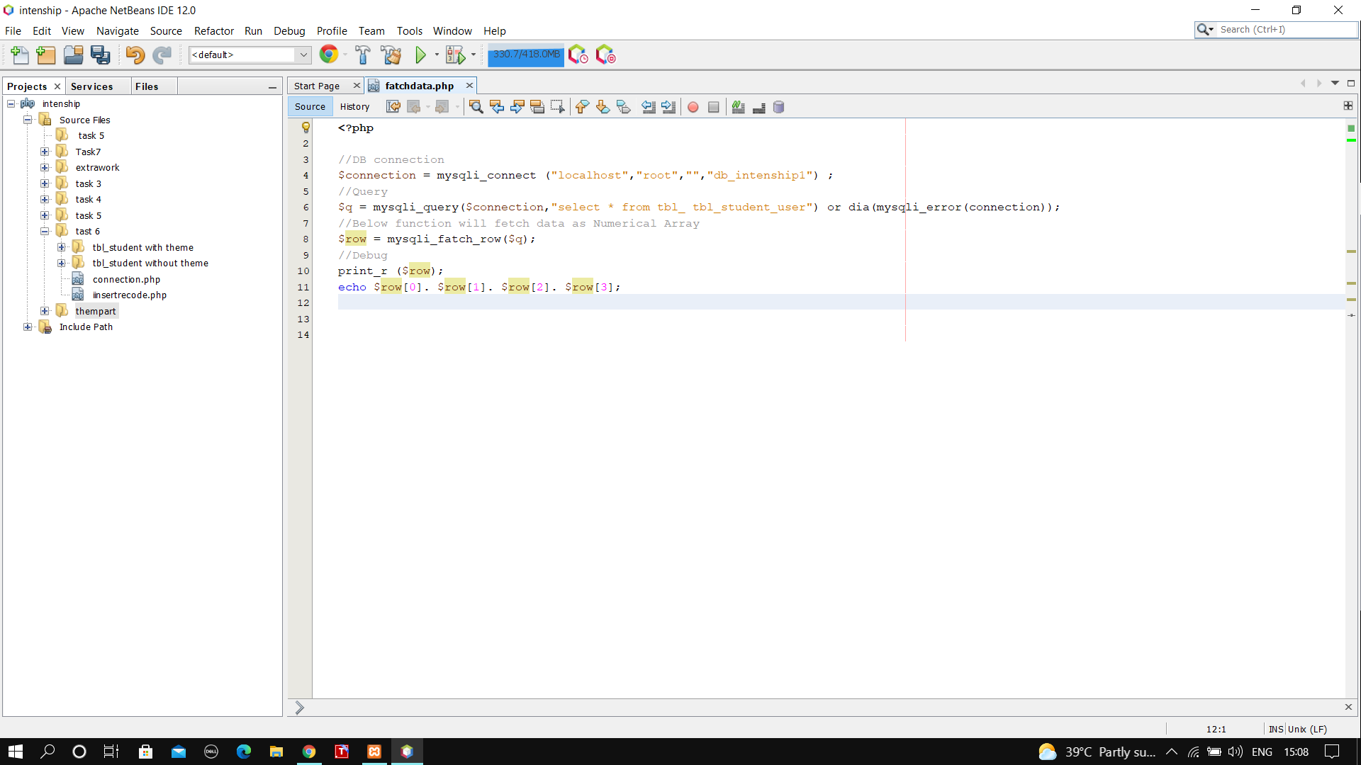

**output**

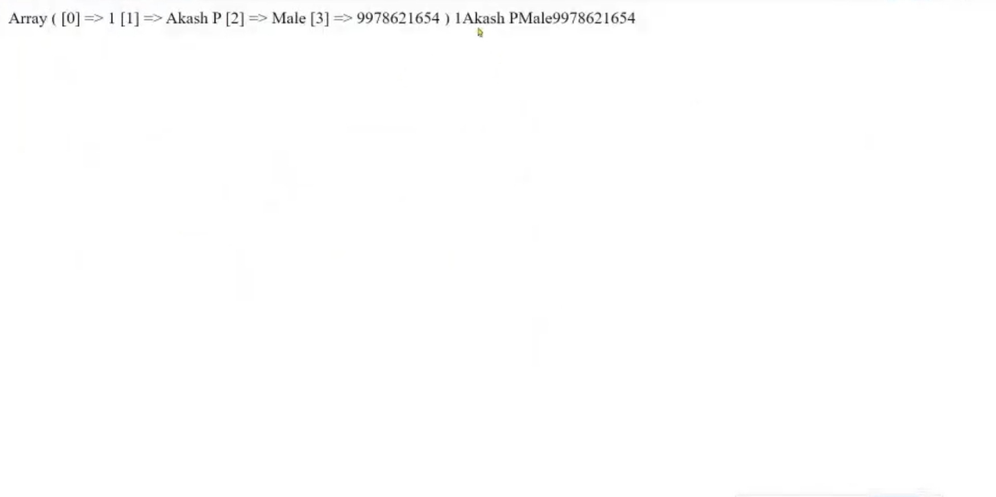

**15 array -implode**

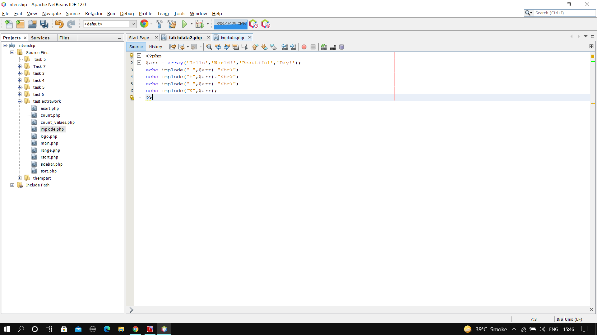**Output**

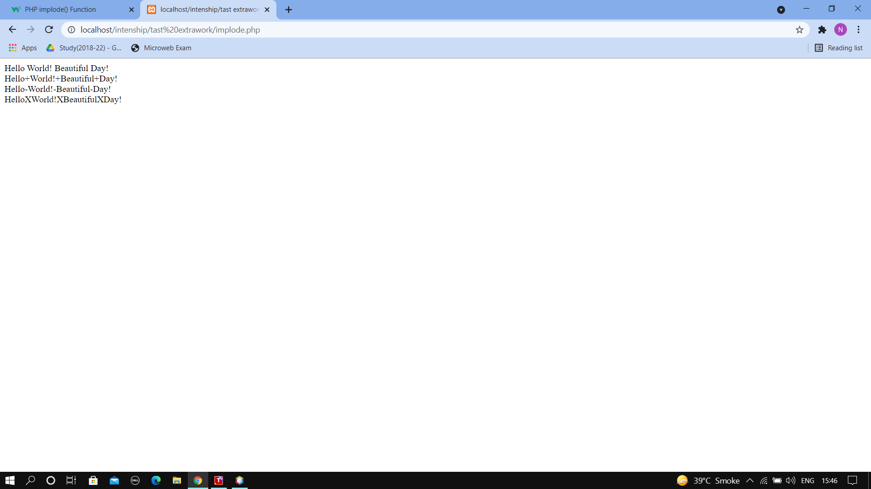

**16. array -explode**

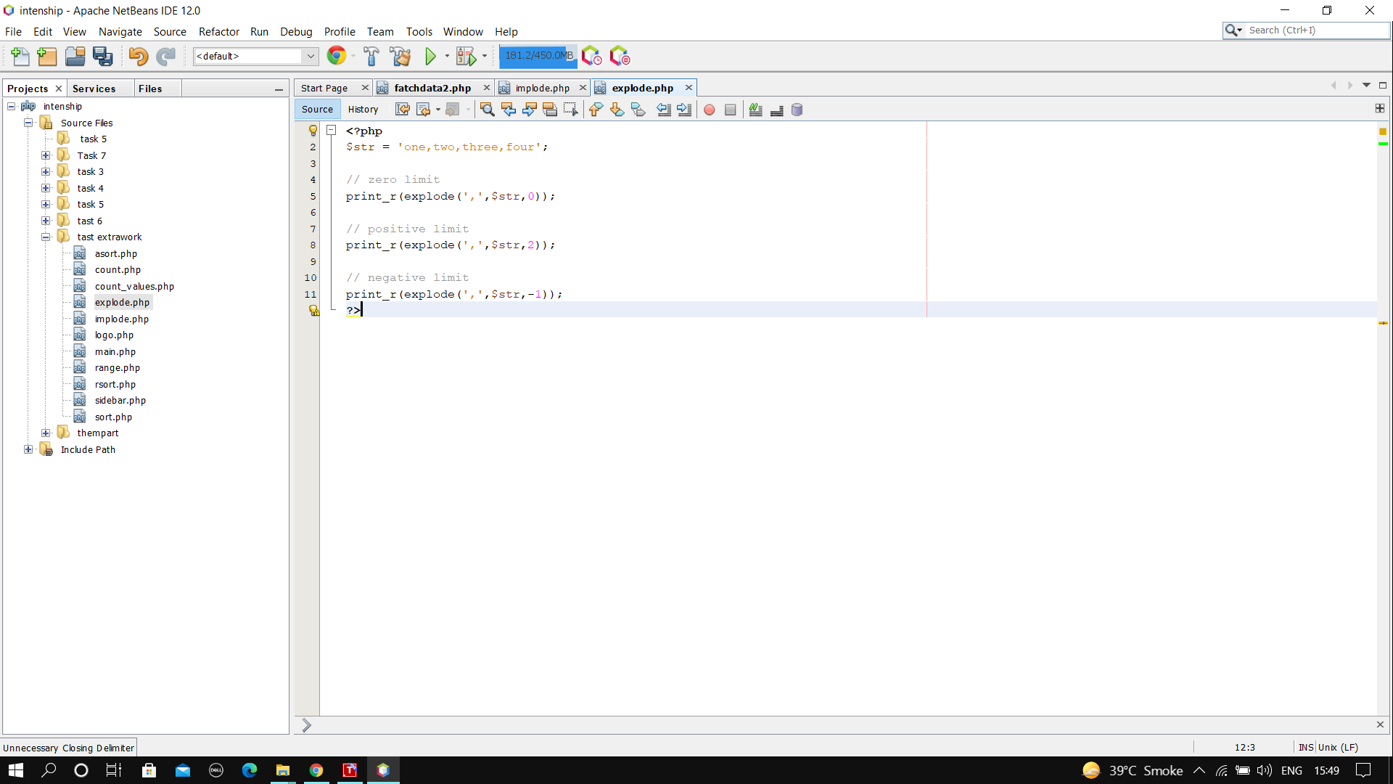**Output**

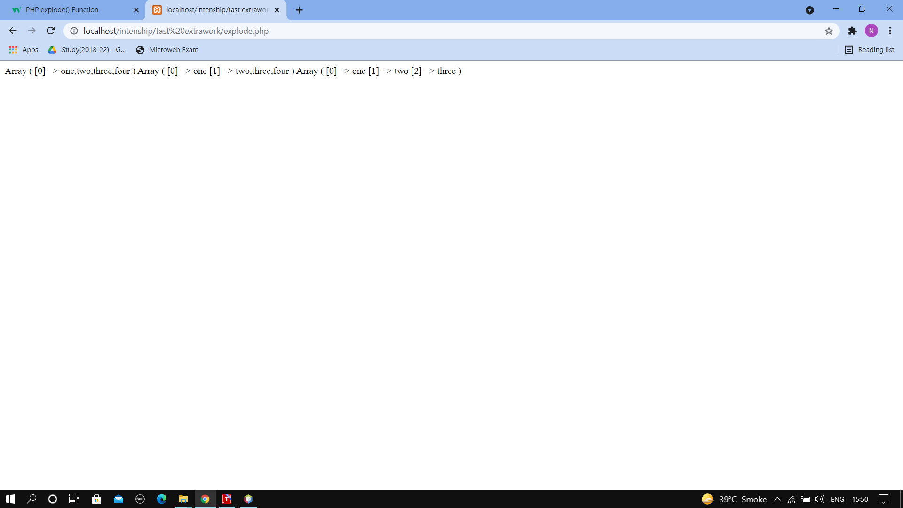

**17.Array -pop**

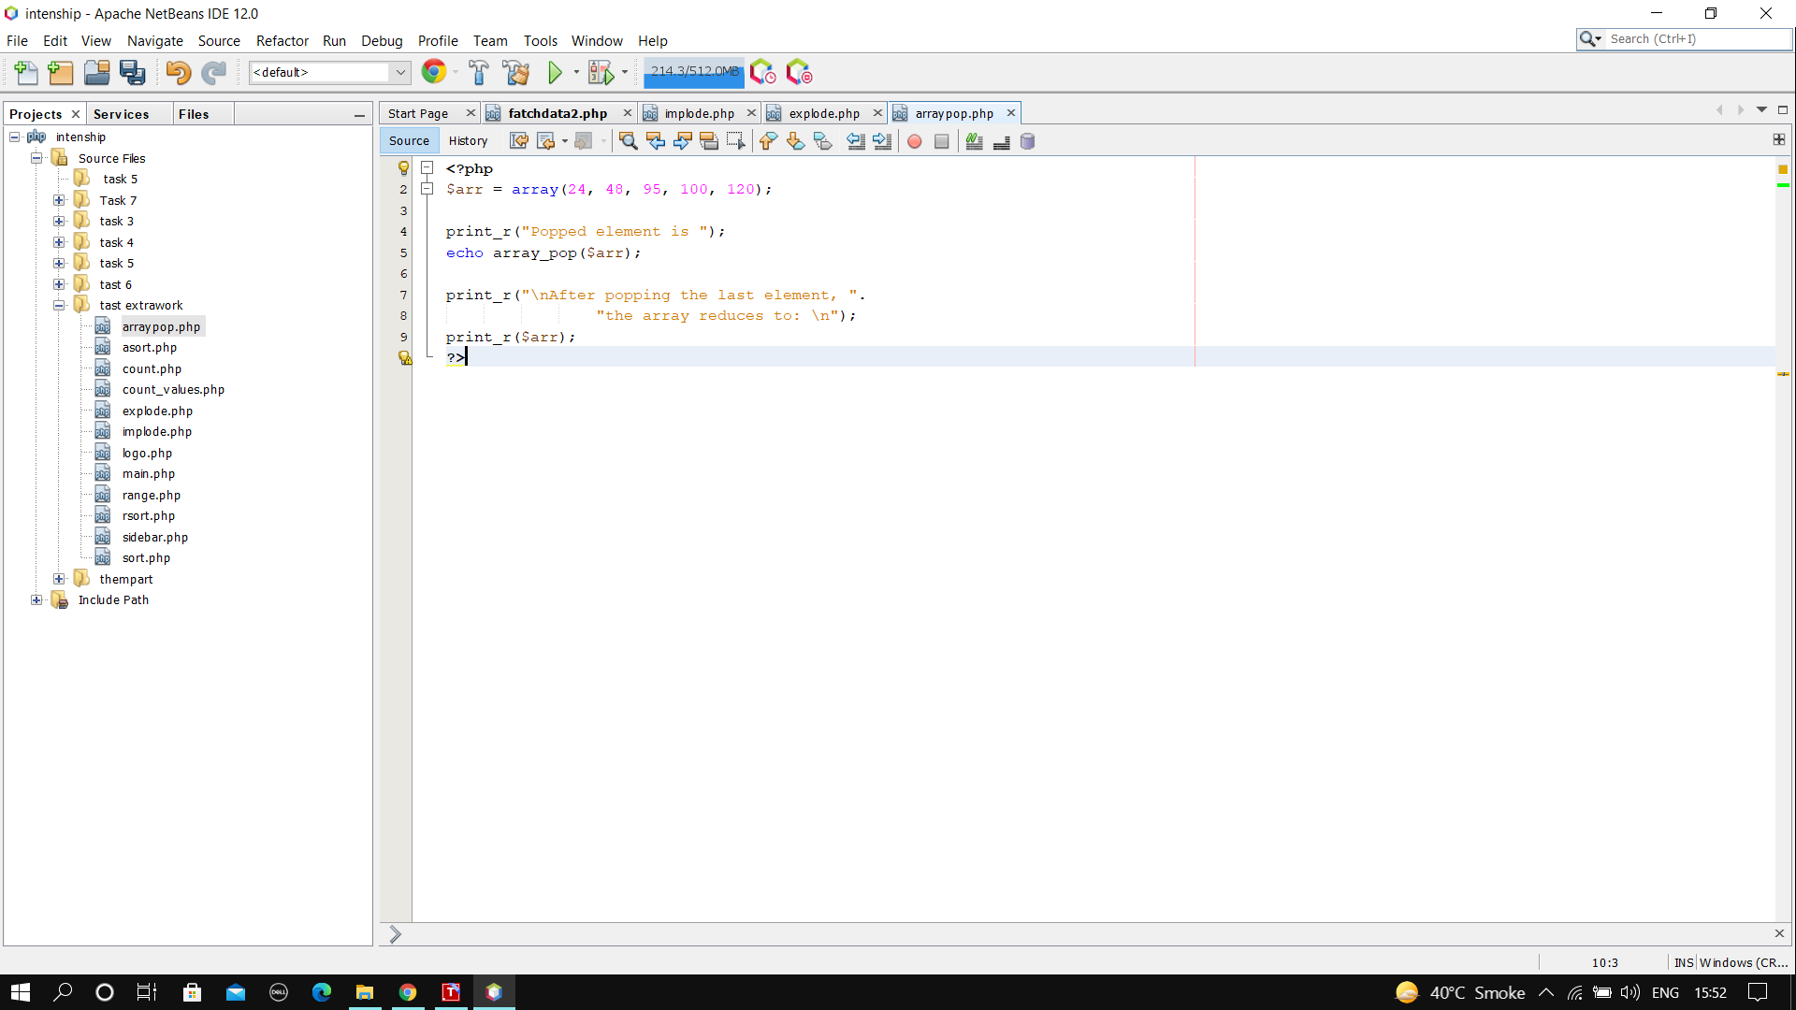**Output**

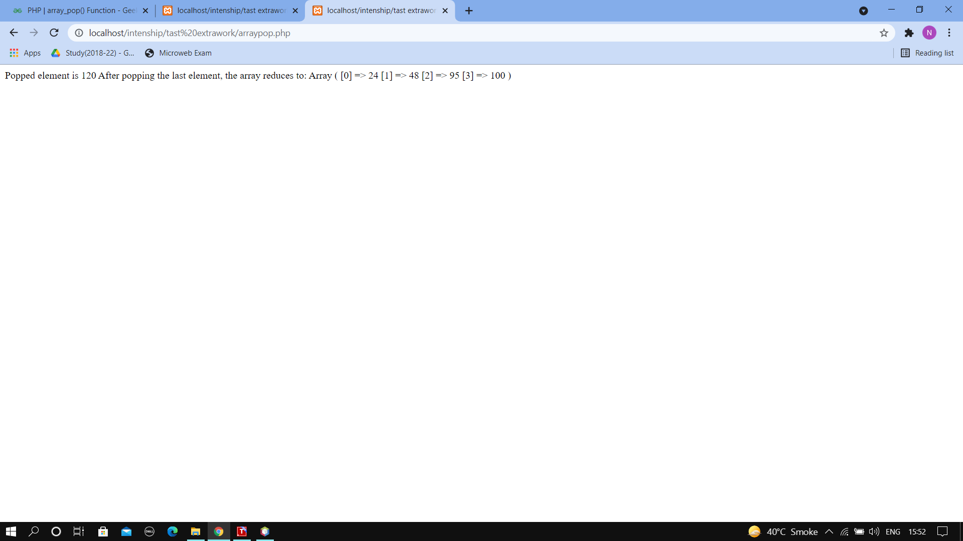

**18.array -push**

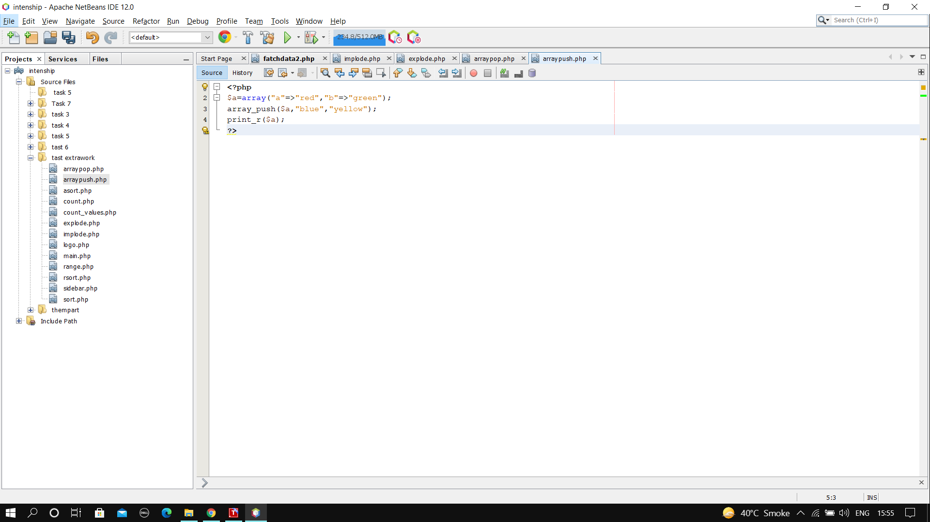**Output**

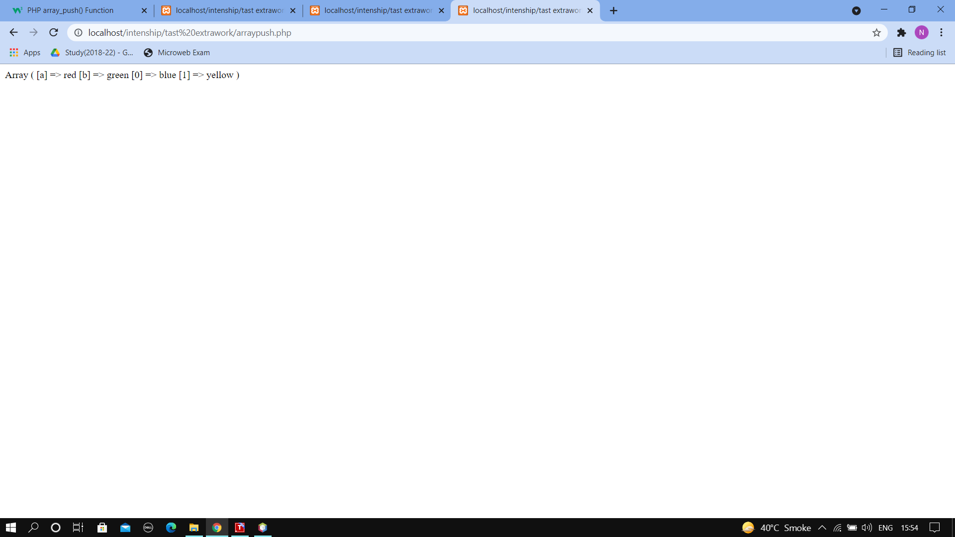

**19.array- diff**

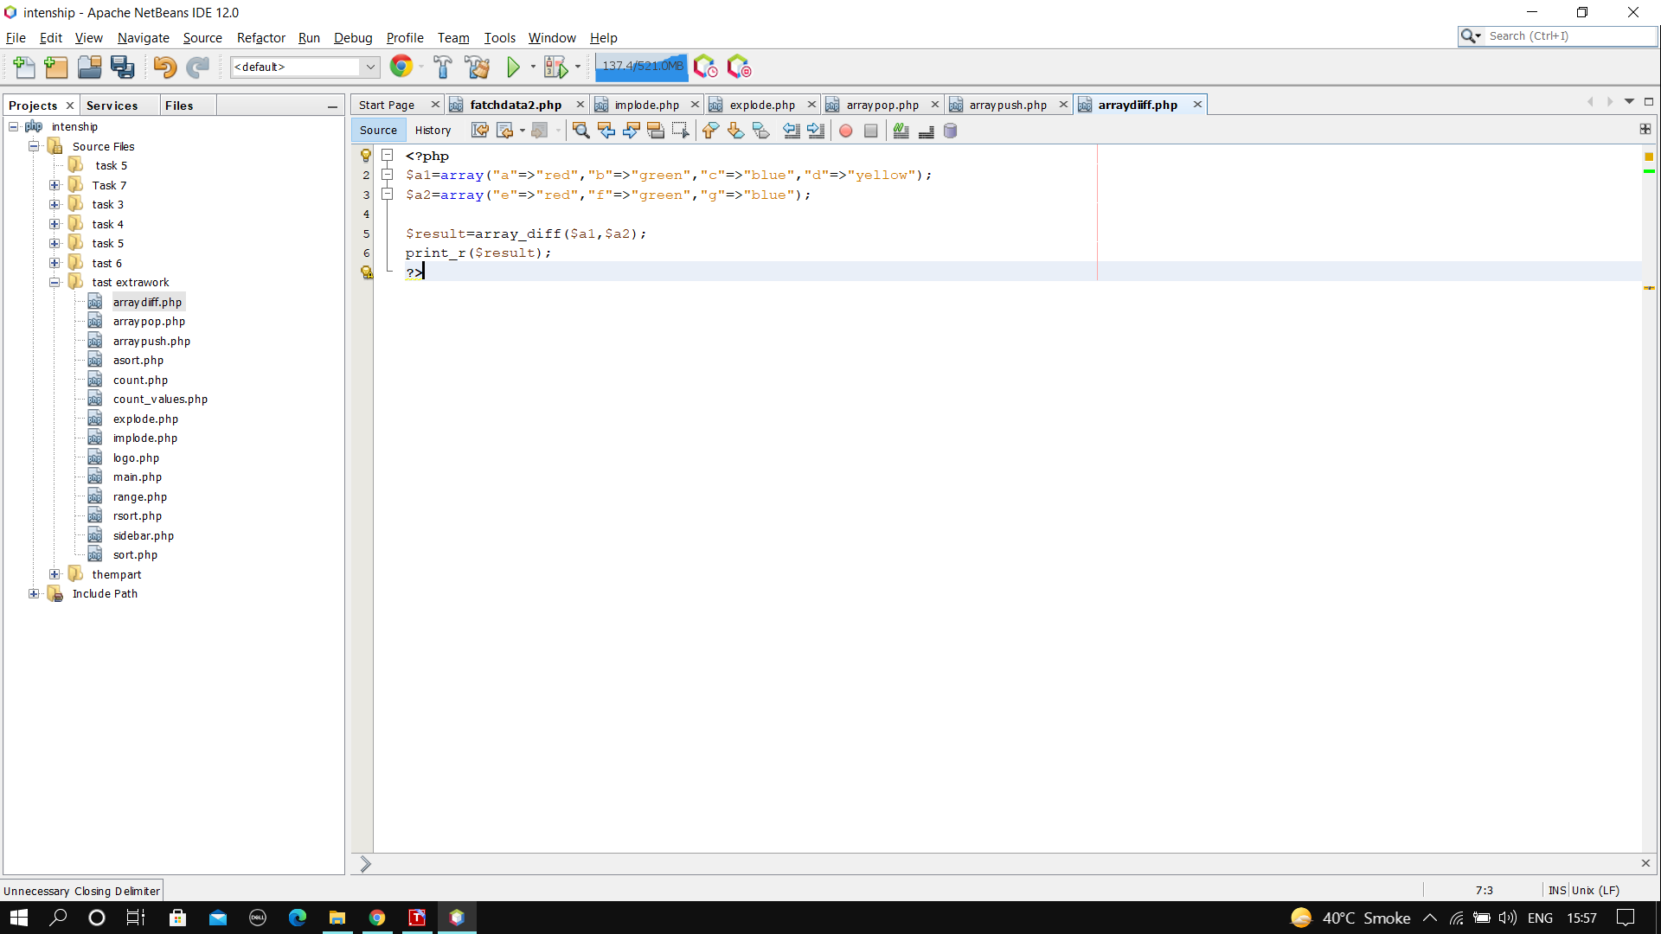**Output**

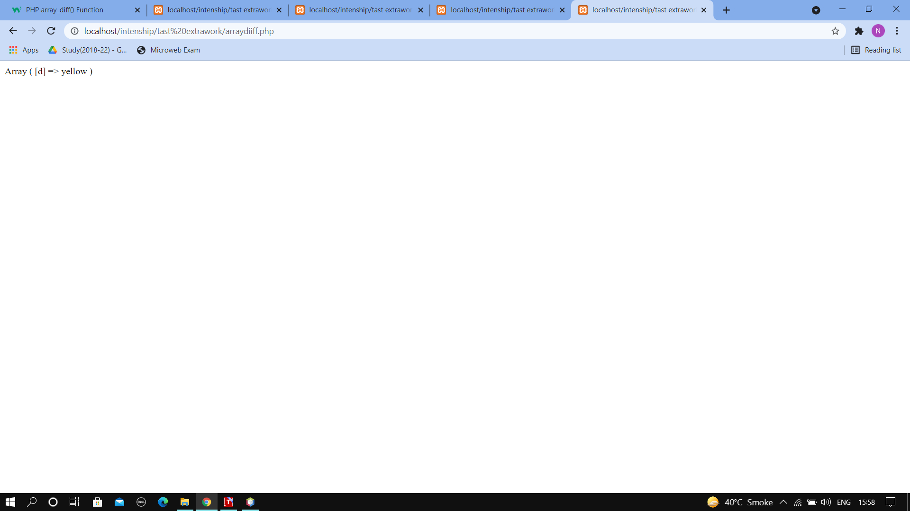

**20.array -combine**

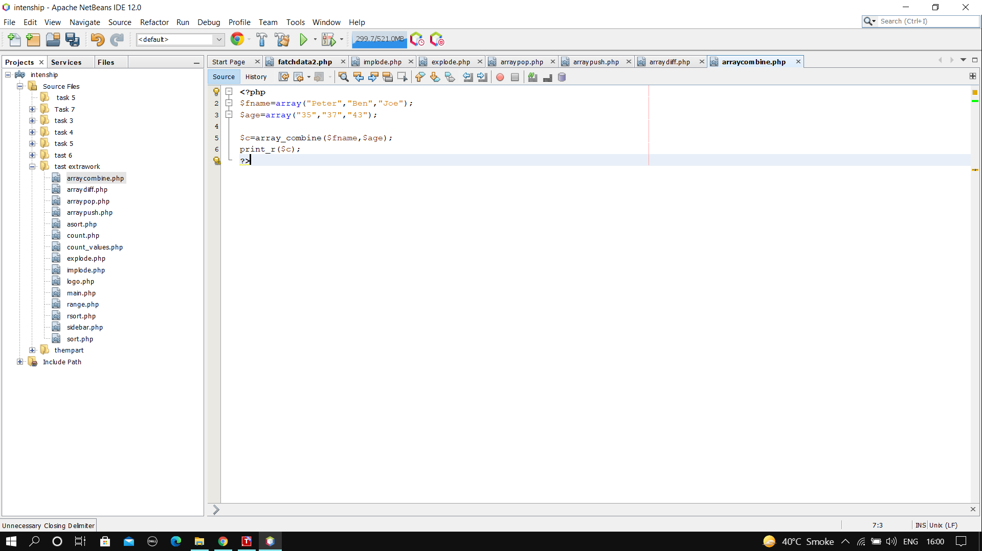**Output**

